
Photoshop, Intermediate
Webworks – A Workshop Series in Web Design (Session Four)

Table of Contents:
- Overview
- Picture Acquisition
- Selection Tools
- Layers and Masks
- Editing Tools
- Filters (truncated)
- Net Resources

- Overview
Photoshop is very, well, comprehensive, meaning that there are most likely three or more ways to do any task. For example, to zoom, you can either scroll the mouse wheel, use the Navigator window, use the Zoom Tool, open the View menu, or hit the shortcut keys. This may seem intimidating, but hey, this way you’ll probably learn at least one way to do what you want. Experimentation is the best way to learn, so right click, try holding down shift or ctrl (apple for some) or alt. Play around and you will learn.

- Picture Acquisition
Besides simply opening files or copying them from another source on the computer, Photoshop offers extensive scanning support. To scan a picture, go to File, Import, then pick your scanner.

- Selection Tools
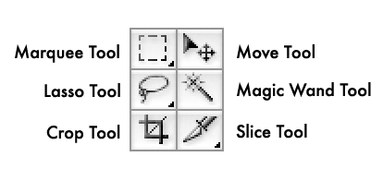
The Marquee, Lasso, and Magic Wand Tools allow you to select parts of the picture for editing. The Move Tool, as its name suggests, allows you to move selections and layers around. Crop resizes the picture to the selected area (notice the options given in the, well, Options Bar) while the Slice Tool is used to divide an image into distinct, separate parts when saving into another format, without the hassle of maintaining several different image files. It’s a tool used mostly by web developers in creating rollovers for websites.

Holding down your left mouse button over the Marquee and Lasso Tools will allow you to access additional selection tools, such as the ability to select in different shapes with the Marquee and Polygonal Lasso and Magnetic Lasso with the Lasso Tool. Try playing around with the magnetic lasso tool.
PRACTICE – Find a picture on the internet of anything you fancy so long as it has a nice outline. Practice selecting one given object of the picture at a time, using the various selection tools. Note that certain tools are better for certain objects than others; the circle marquee tool is great for selecting soccer balls and the like while the magnetic lasso is good for cutting out dark objects on light background or vice versa.

- Layers
You should already know pretty much what a layer is, however much may still confusing. Thus, here’s a handy, dandy diagram to dispel confusion:

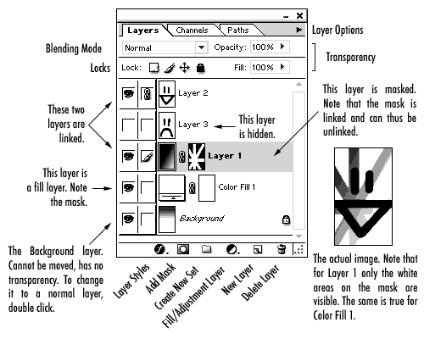

When layers are linked together, they move simultaneously, change size proportionately, etc.

Fill/Adjustment Layer – Fill and adjustment layers let you do things like put in a Solid or Gradient (that automatically expands and shrinks unlike the Gradient Tool, which paints a gradient onto the canvas), adjust the color and saturation of the all layers underneath using Hue/Saturation, or do really cool funky effects using Gradient Maps. Note that all Fill/Adjustment Layers automatically include a mask:

Masks – Think of a mask as one of those envelopes with the clear cellophane window; wherever the mask is white, that’s the clear window, wherever it’s black, that’s the opaque envelope. You can simply draw black or white on with the brush tool (or any shade of gray in between) or you can create vector-based shapes that will mask or show the image. You can also alt-click the mask in the layers menu to see only the black and white.

PRACTICE – Take the picture you cut out before, make the selection, and create a new adjustment or fill layer (take your pick). Your image will have the adjustment or fill applied to the places you selected. In the Layer Window, you’ll be able to select between the adjustment/fill layer and the associated mask by clicking the appropriate thumbnail window. Try changing the mask by using the brush tool and drawing in black or white. Now, delete the mask from the adjustment/fill layer by clicking on it in the Layer Window and dragging it to the trash. The entire picture will now be affected by the adjustment/fill layer.
Editing Tools

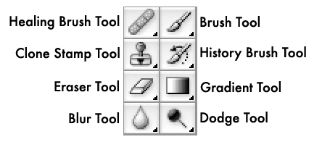
The Healing Brush and Clone Stamp Tools are useful for fixing blemishes on images; associated with the Healing Brush are the Patch Tool and Color Replacement Tool, which we will use to fix red-eye problems. The Pattern Stamp Tool is associated with the Clone Stamp Tool.

To use either the Healing Brush, Clone Stamp, or Patch Tool, one must first select an area from which image data is taken by alt-clicking part of your picture. The color used in the Color Replacement tool is the one currently set as your Foreground Color.

The Brush/Pencil, Eraser, and Gradient/Fill Tools are fairly self-explanatory. Of greater note are the options you have in terms of what brush you use, how color is applied, etc. Play around with these options.

The Blur/Sharpen/Smudge Tools are also fairly self-explanatory. The Dodge/Burn/Sponge Tools refer to photo techniques of “burning” parts of photos during development in order to make areas darker, or “dodging” parts of photos, not allowing them to get as much light, in order to make them brighter. The sponge tool can either desaturate parts of the image, removing the color, or saturate parts of the image, thereby adding color.
PRACTICE – Play around with the editing tools. The best way to start is with the familiar, so select the Brush tool, pick a color that you like, and draw something nice. Maybe a smiley face or a dog. Exciting, no? Now, start fiddling around with it. Try playing connect the dots by holding down shift and clicking all over the page. Change the brush size through the Options Bar or by right-clicking. Notice that some brushes are based on pictures and so look like leaves or grass.

Find a picture on the internet with red eye in it, copy it into Photoshop, select a color appropriate for the eye (probably dark brown) and activate the Color Replacement Tool. With your newfound skill in manipulating brush-based tools, banish that red eye. Good.

- Filters
The filters of Photoshop are various and sundry. In Photoshop version CS and above there is a Filter Gallery that you can utilize to look through images. One filter, in particular, that is useful in this era of online imagery is the Median filter, located below Sharpen. This filter allows you to remove JPEG distortion, even in massively blown up images, by normalizing nearby pixels.

PRACTICE – Another very useful filter is the Gaussian Blur. You can use this filter to soften pictures or, if you’re crafty, to soften selections. To do so, first make your selection, using whatever means you like. Now, switch into Quick Mask Mode by either clicking the button in the Tool Bar or by hitting the button ‘q’. Notice that your current selection is made visible. From the Filters menu, choose Gaussian Blur and select a level of blurriness that you like. Apply the filter and hit the Quick Mask Mode button (or ‘q’) again to return to normal mode. Though it may not look like it, your selection is now fuzzy. Try this in conjunction with adjustment/fill layers.
- Net Resources
Tutorials – Photoshop is popular, as any google search will inform you. Here are a couple of my personal favorite sites.
  - http://www.aqa-d.se/ny/pstips/fwf_all.htm
  - http://www.thewebmachine.com/ - click “photoshop”, the tutorials are on the left
  - http://www.cgtalk.com – find “photoshop”, it’s halfway down the page, there should be a large list of tutorials on there.

Fonts – http://www.dafont.com/en/ - Contains a giant selection of high quality fonts for free.

